Nama : Aliffio Syah M

NIM : 41519120065

Mata Kuliah : Pemrograman Web Enterprise

**Tugas Pertemuan 8**

Create new page to insert, update & delete from table petugas

**Screenshot page list**

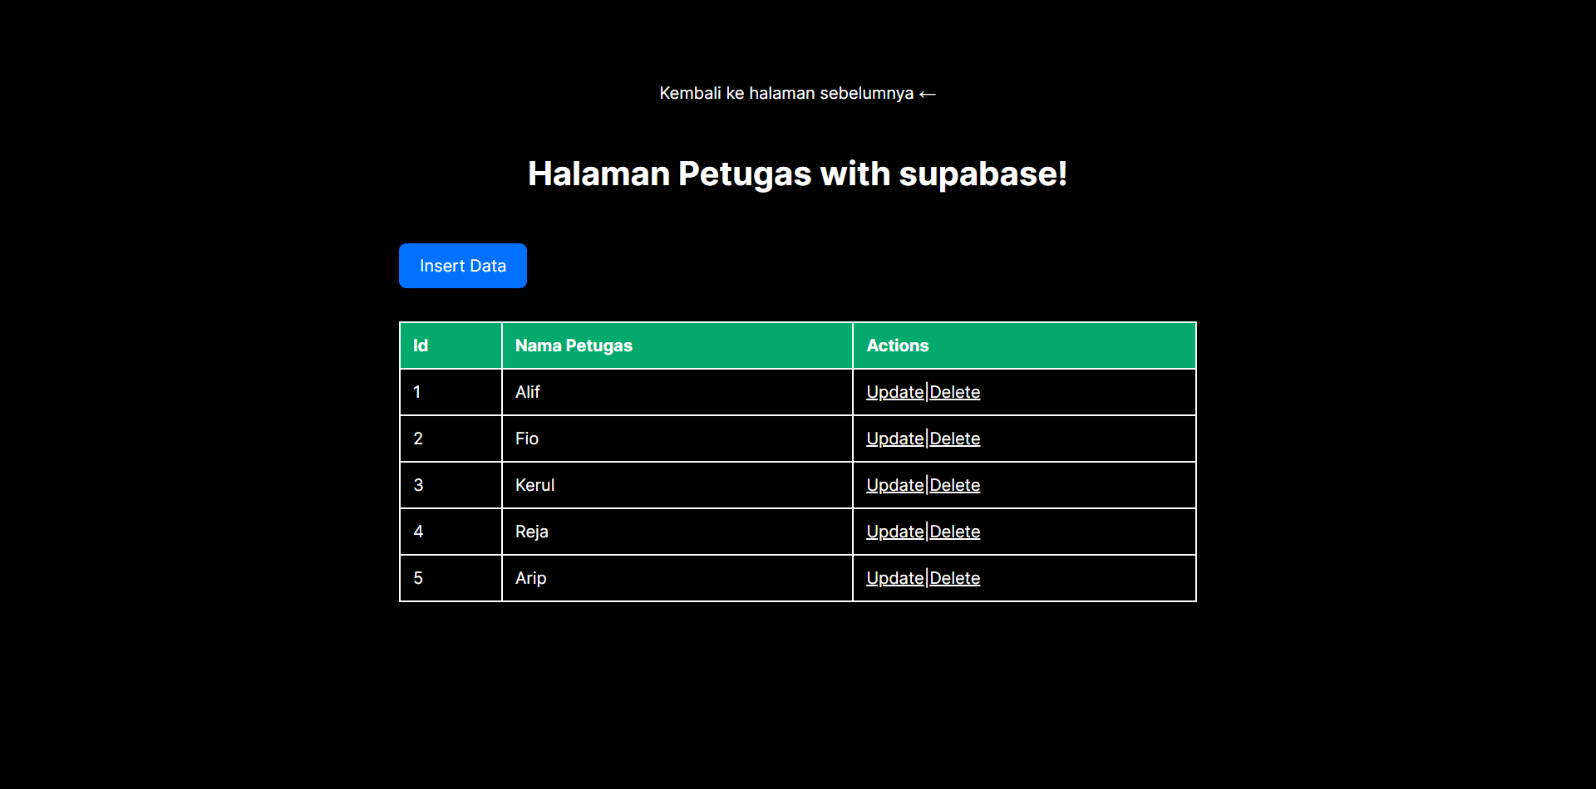

**Screenshot page insert**



**Screenshot page after insert**

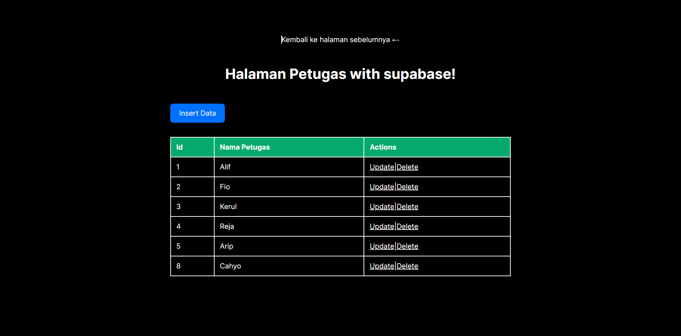

**Screenshot page update**

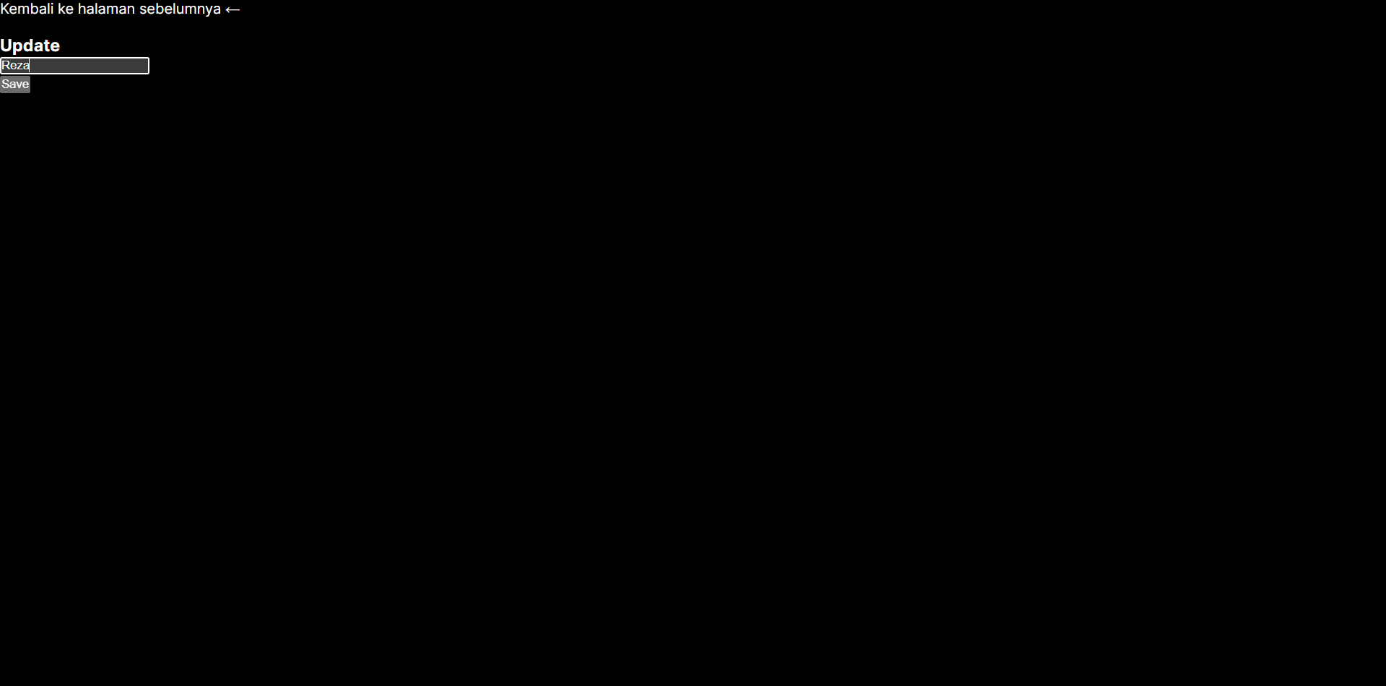

**Screenshot page after update**

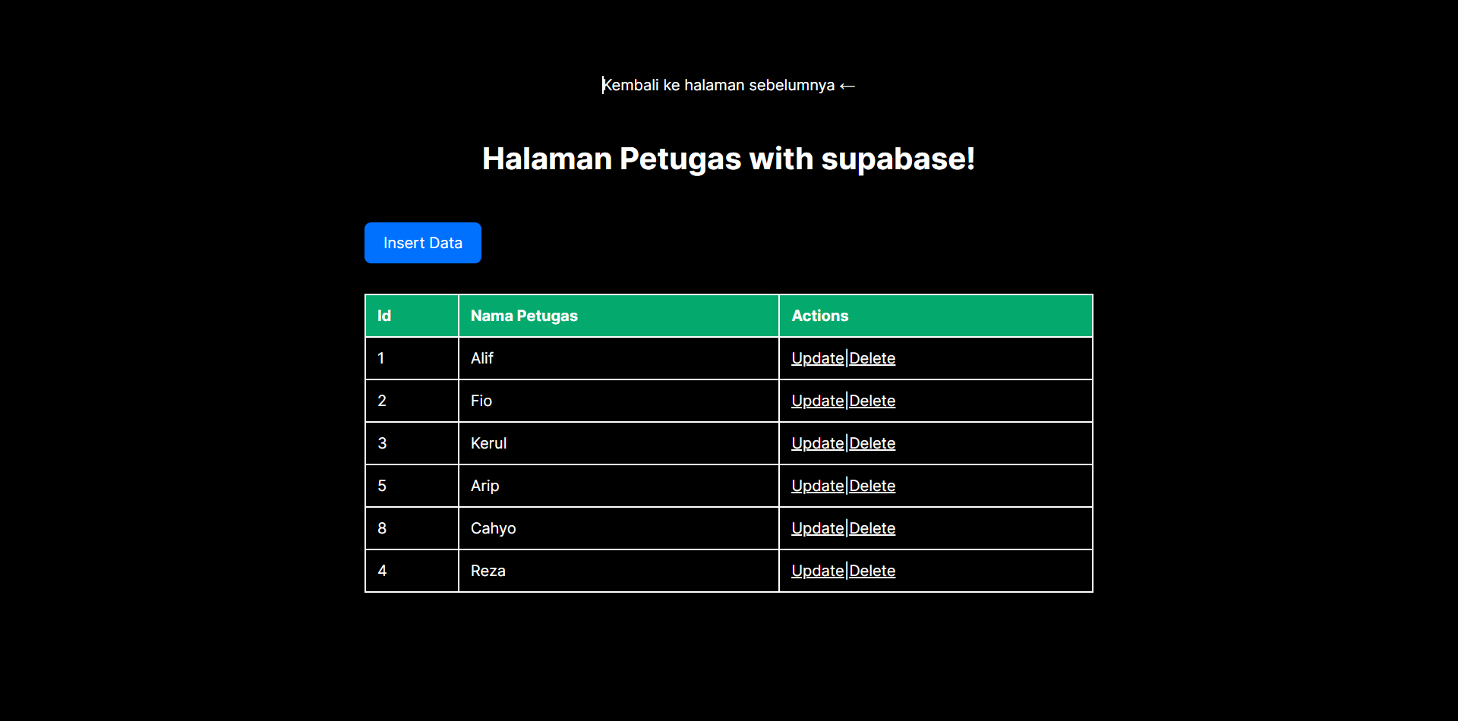

**Screenshot page delete with confirmation message**

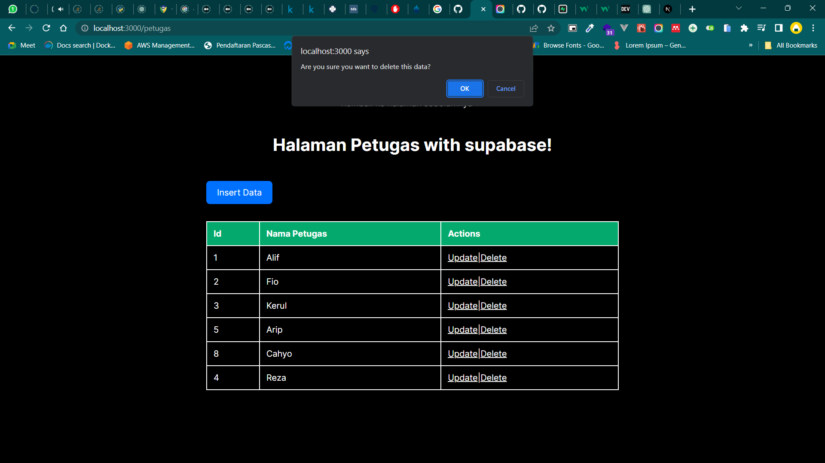

**Screenshot code for insert process**

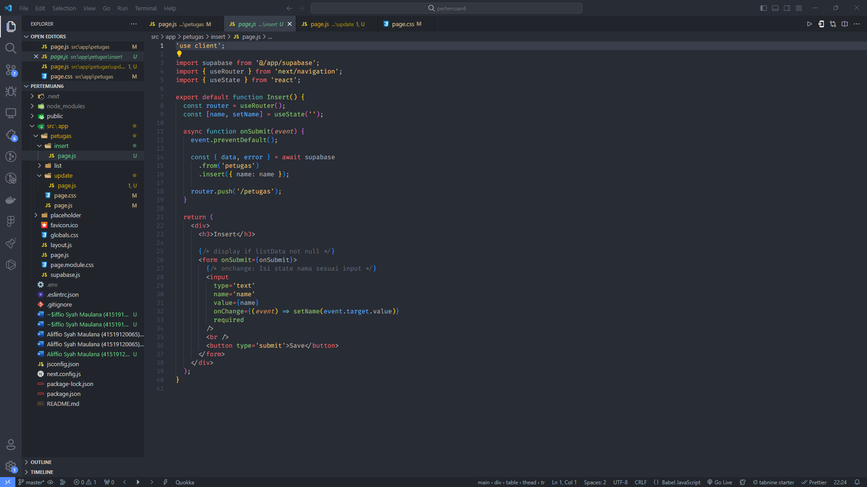

**Screenshot code for edit process**

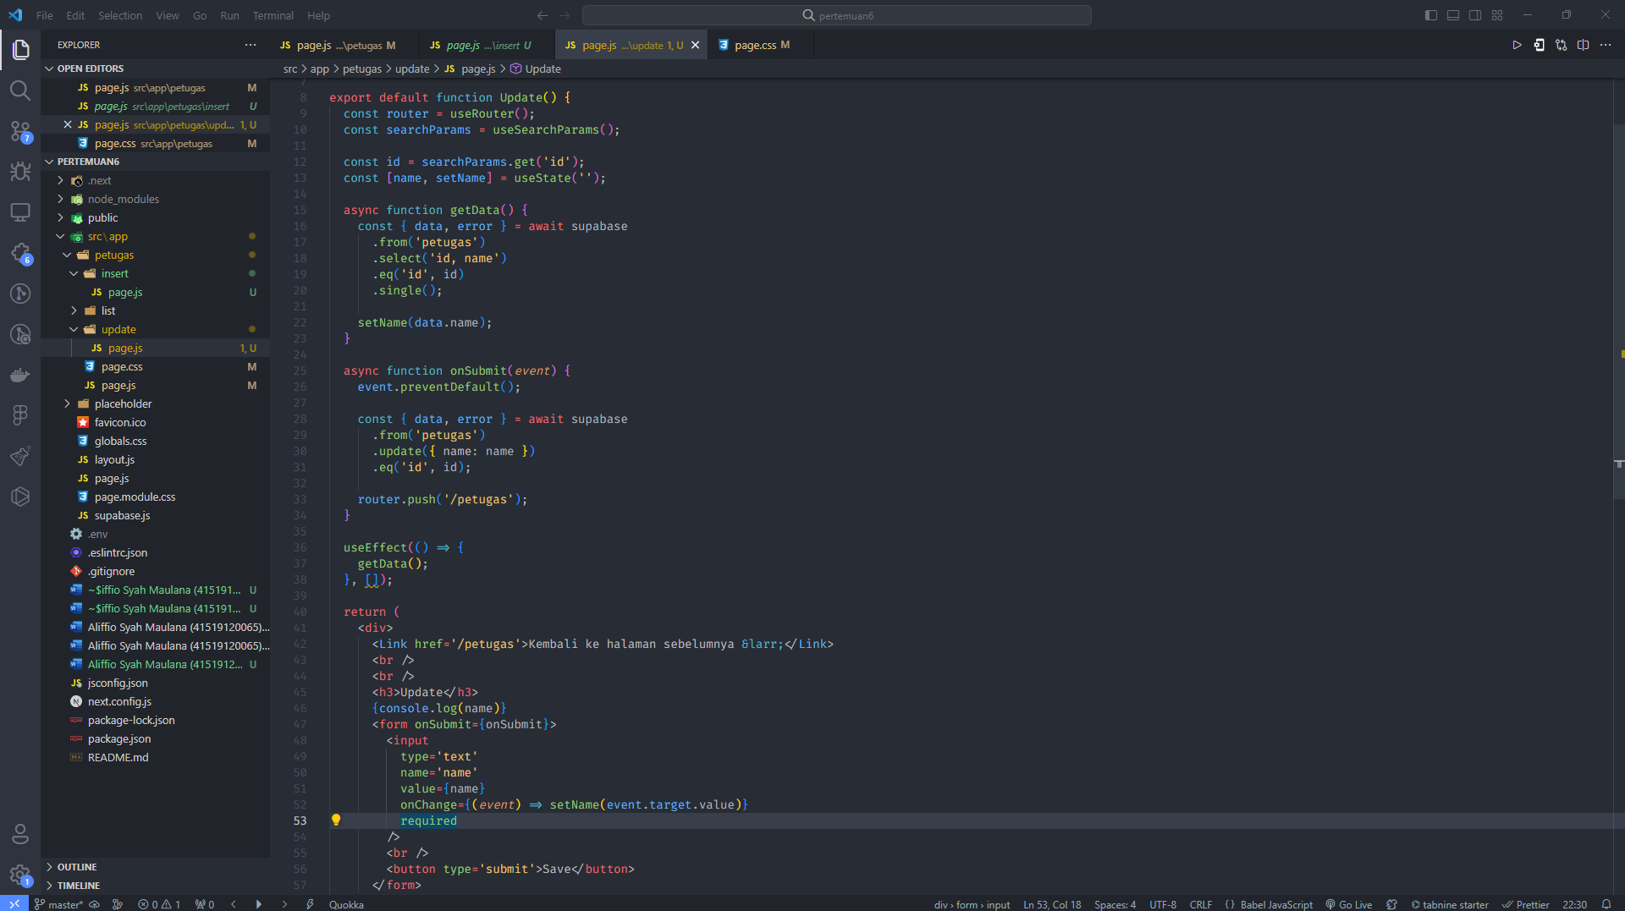

**Screenshot code for delete process with confirmation message**

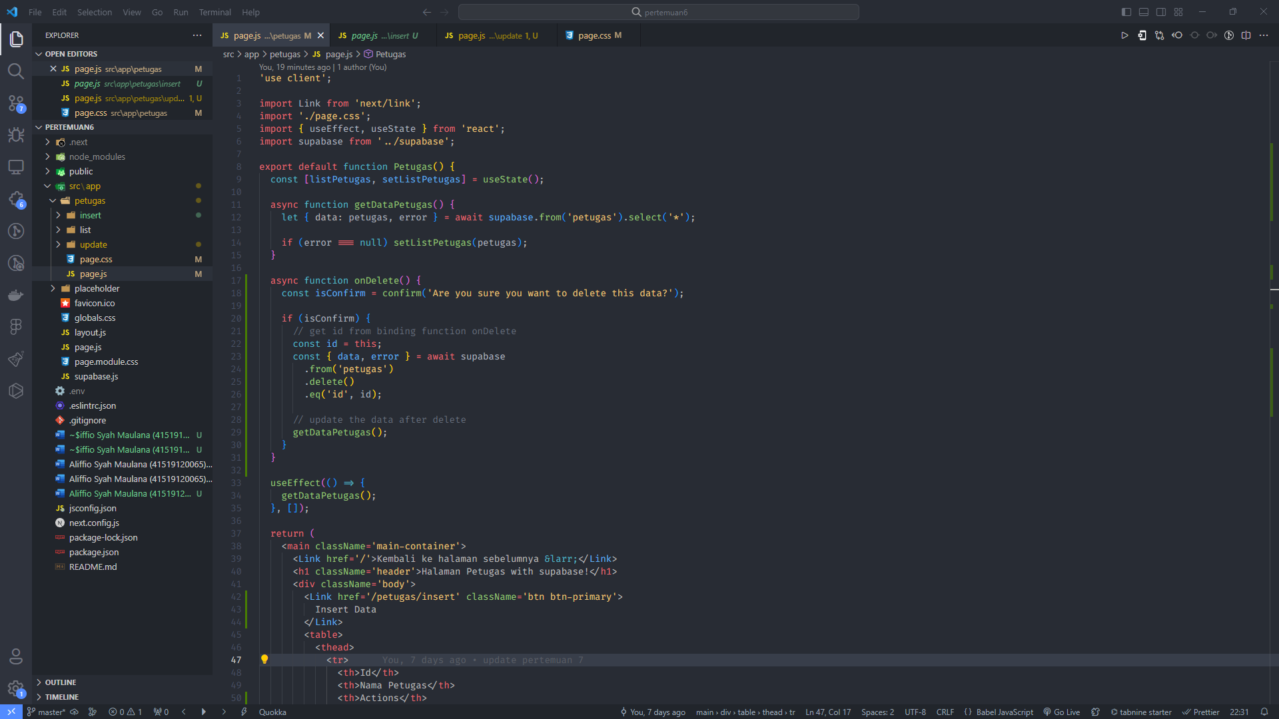

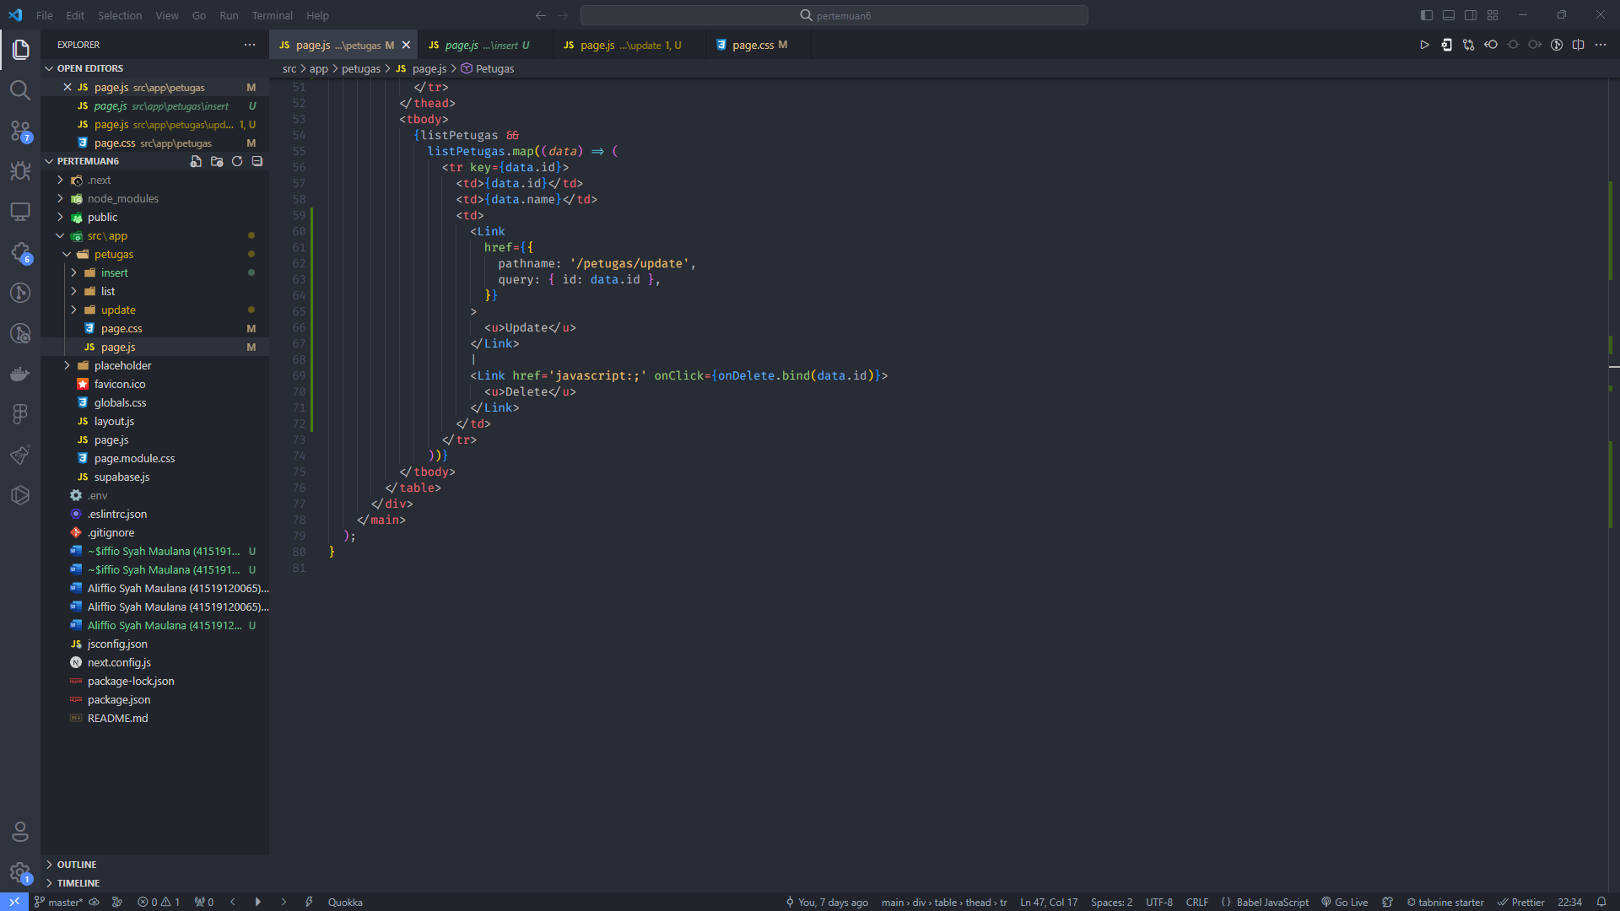

**Complete Code in Github:**

<https://github.com/alif-syhm01/pemrograman-web-enterprise-pertemuan6.git>